Name: Saad Ahmad Roll number: 20P-0051

Section: BS (CS) - 2D1

**Using NAND Gate to make other logic gates:**

**NOT Gate:**

**Combination#1**

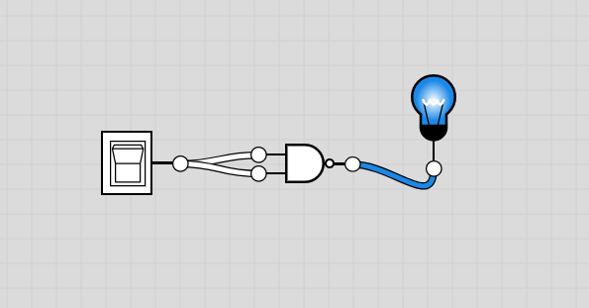

|  |  |
| --- | --- |
| Input | Output |
| 0 | 1 |

**Combination#2**

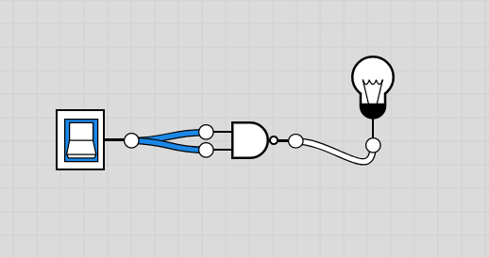

|  |  |
| --- | --- |
| Input | Output |
| 1 | 0 |

**AND Gate:**

**Combination#1**

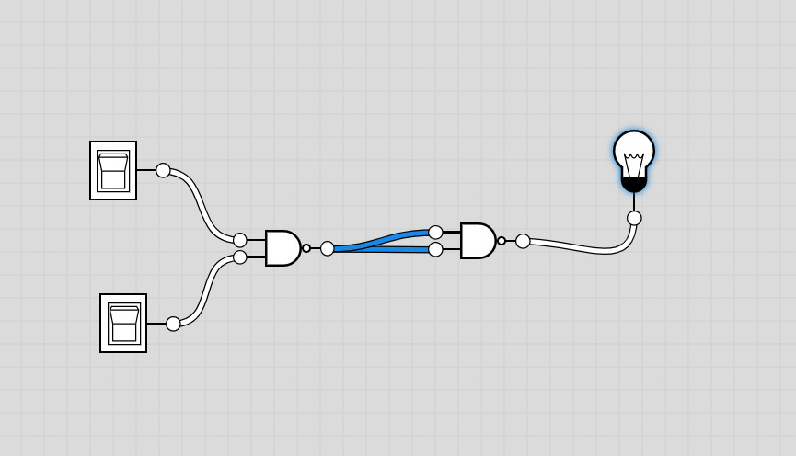

|  |  |  |
| --- | --- | --- |
| Input 1 | Input 2 | Output |
| 0 | 0 | 0 |

**Combination#2**

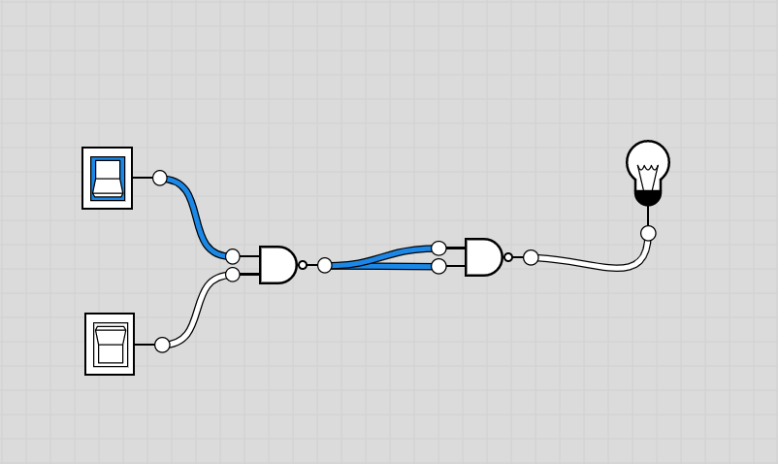

|  |  |  |
| --- | --- | --- |
| Input 1 | Input 2 | Output |
| 1 | 0 | 0 |

**Combination#3**

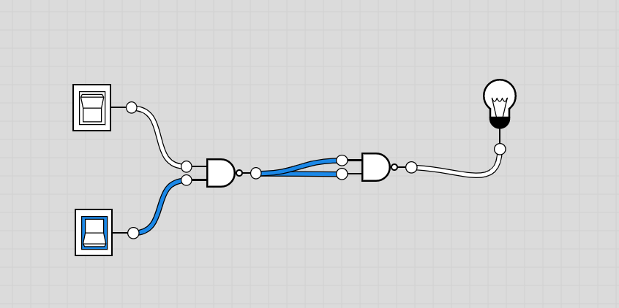

|  |  |  |
| --- | --- | --- |
| Input 1 | Input 2 | Output |
| 0 | 1 | 0 |

**Combination#4**

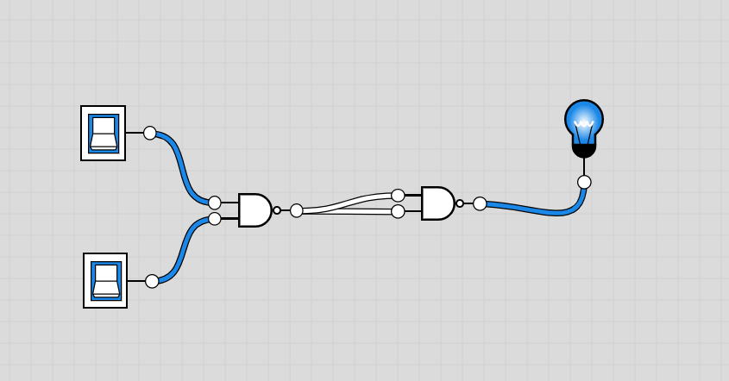

|  |  |  |
| --- | --- | --- |
| Input 1 | Input 2 | Output |
| 1 | 1 | 1 |

**OR Gate:**

**Combination#1**

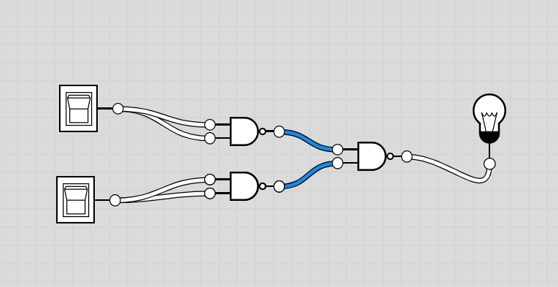

|  |  |  |
| --- | --- | --- |
| Input 1 | Input 2 | Output |
| 0 | 0 | 0 |

**Combination#2**

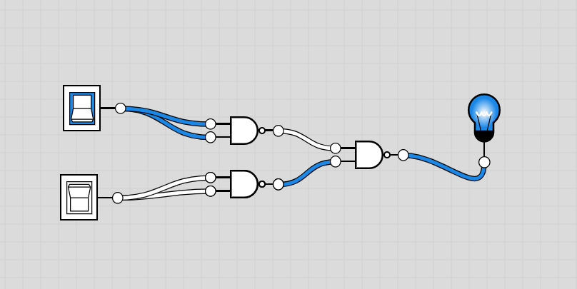

|  |  |  |
| --- | --- | --- |
| Input 1 | Input 2 | Output |
| 1 | 0 | 1 |

**Combination#3**

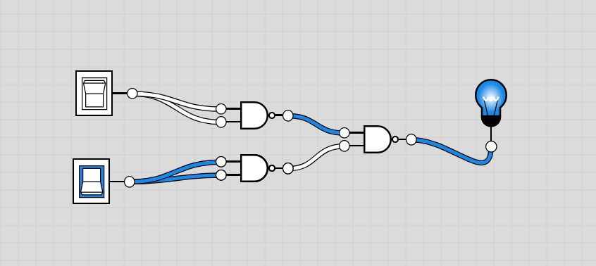

|  |  |  |
| --- | --- | --- |
| Input 1 | Input 2 | Output |
| 0 | 1 | 1 |

**Combination#4**

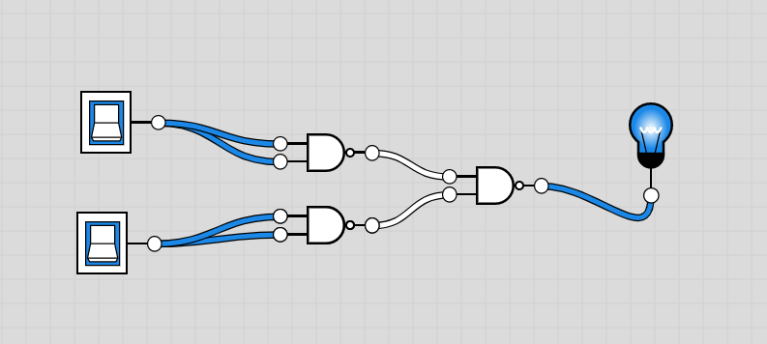

|  |  |  |
| --- | --- | --- |
| Input 1 | Input 2 | Output |
| 1 | 1 | 1 |

**NOR Gate:**

**Combination#1**

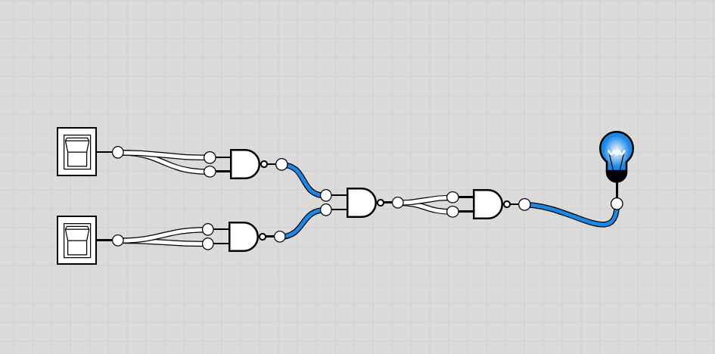

|  |  |  |
| --- | --- | --- |
| Input 1 | Input 2 | Output |
| 0 | 0 | 1 |

**Combination#2**

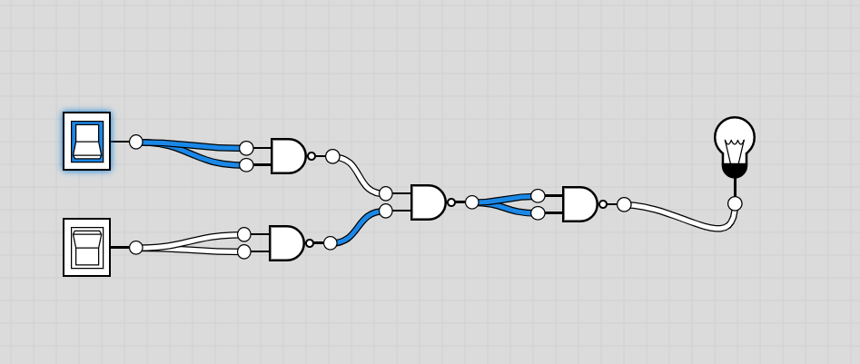

|  |  |  |
| --- | --- | --- |
| Input 1 | Input 2 | Output |
| 1 | 0 | 0 |

**Combination#3**

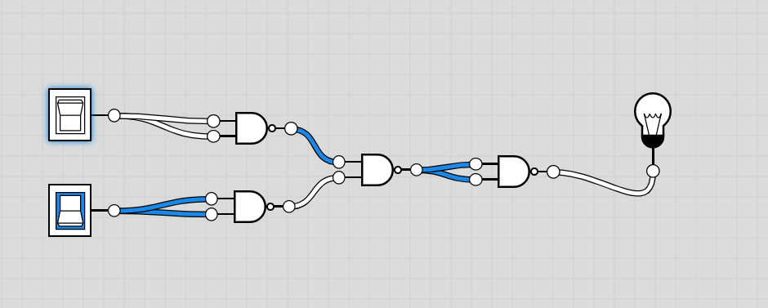

|  |  |  |
| --- | --- | --- |
| Input 1 | Input 2 | Output |
| 0 | 1 | 0 |

**Combination#4**

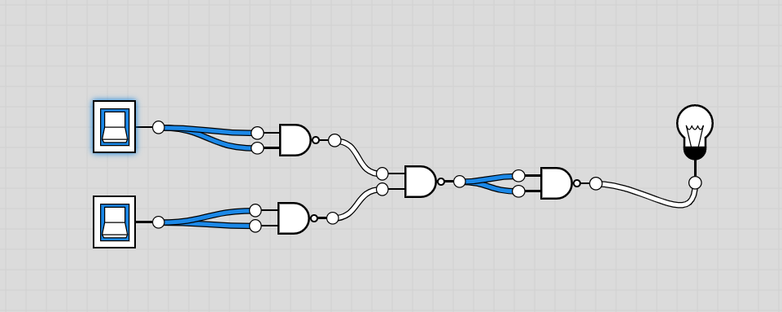

|  |  |  |
| --- | --- | --- |
| Input 1 | Input 2 | Output |
| 1 | 1 | 0 |

**Ex-OR Gate:**

**Combination#1**

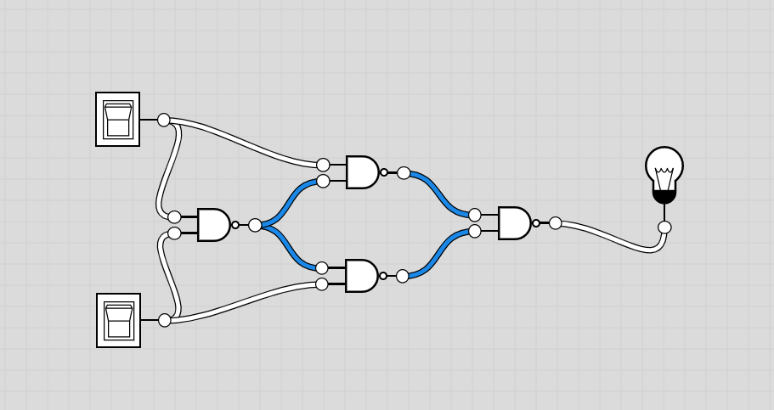

|  |  |  |
| --- | --- | --- |
| Input 1 | Input 2 | Output |
| 0 | 0 | 0 |

**Combination#2**

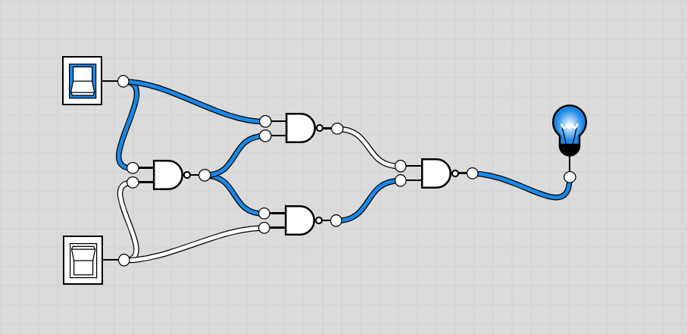

|  |  |  |
| --- | --- | --- |
| Input 1 | Input 2 | Output |
| 1 | 0 | 1 |

**Combination#3**

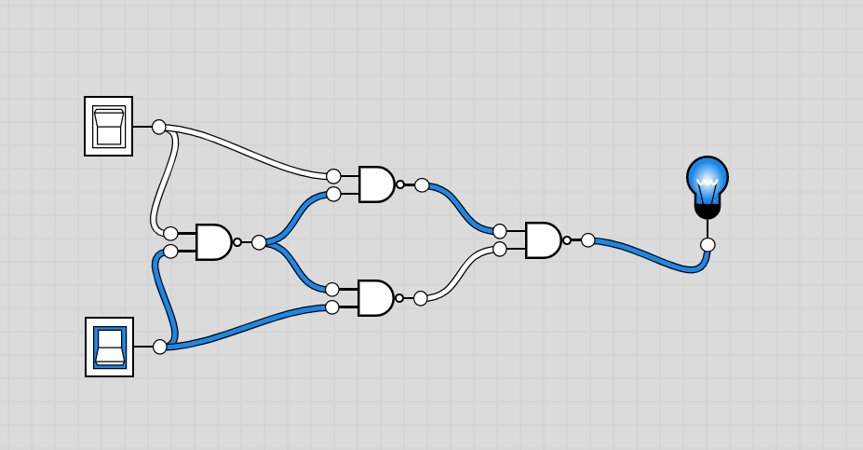

|  |  |  |
| --- | --- | --- |
| Input 1 | Input 2 | Output |
| 0 | 1 | 1 |

**Combination#4**

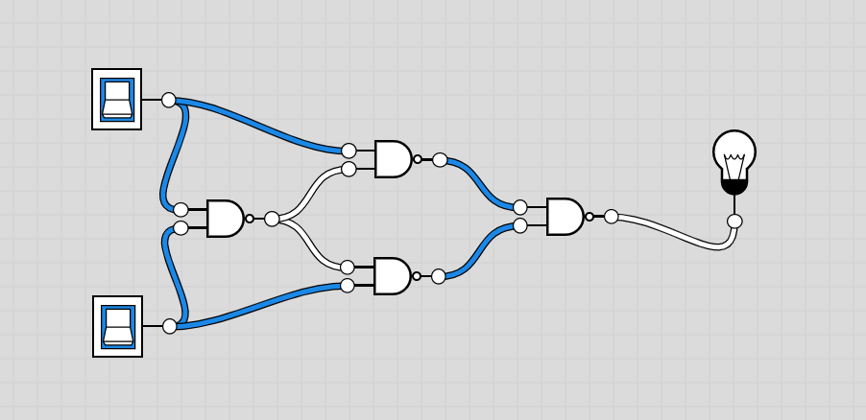

|  |  |  |
| --- | --- | --- |
| Input 1 | Input 2 | Output |
| 1 | 1 | 0 |

**Ex-NOR Gate:**

**Combination#1**

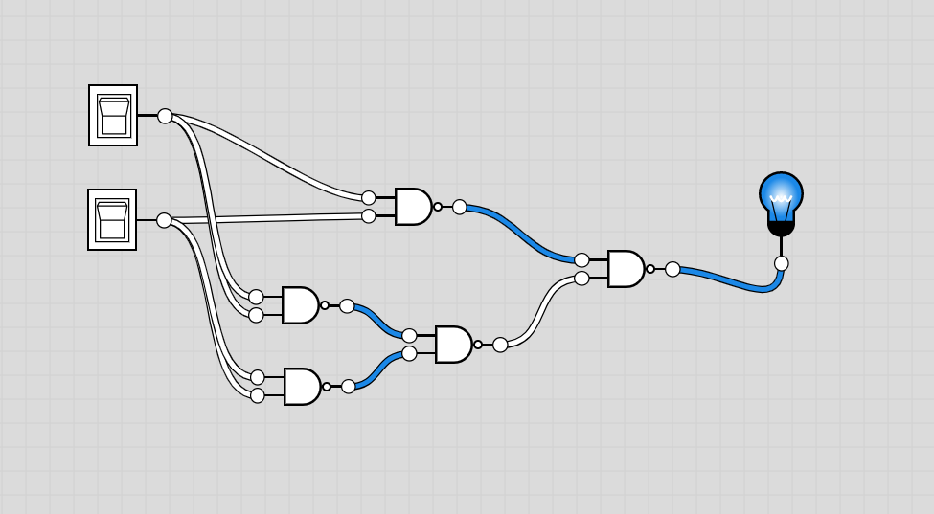

|  |  |  |
| --- | --- | --- |
| Input 1 | Input 2 | Output |
| 0 | 0 | 1 |

**Combination#2**

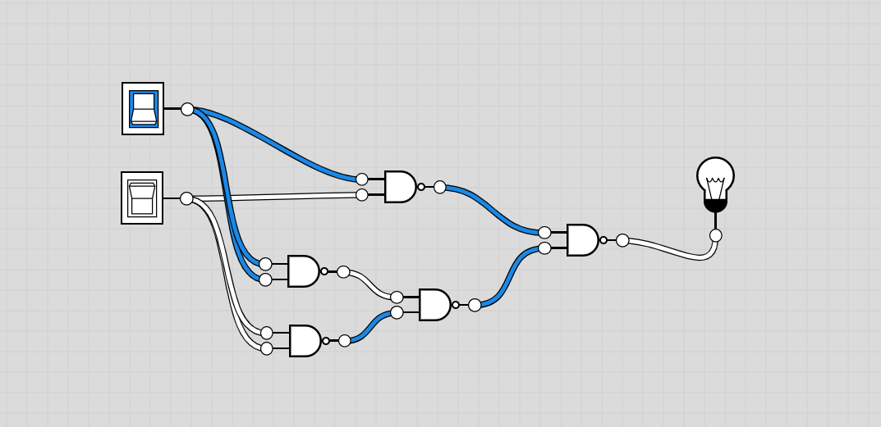

|  |  |  |
| --- | --- | --- |
| Input 1 | Input 2 | Output |
| 1 | 0 | 0 |

**Combination#3**

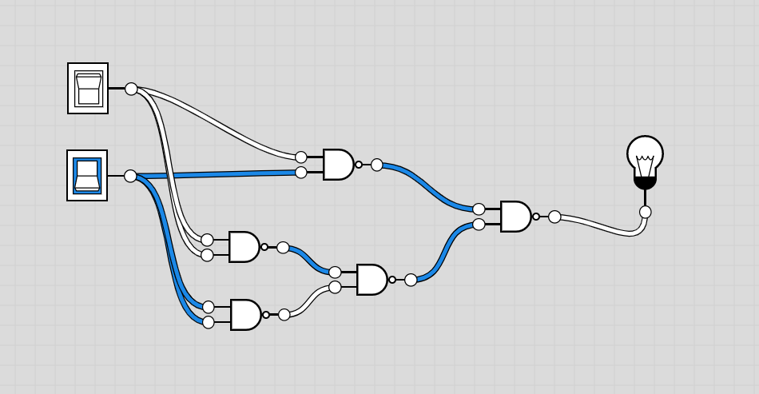

|  |  |  |
| --- | --- | --- |
| Input 1 | Input 2 | Output |
| 0 | 1 | 0 |

**Combination#4**

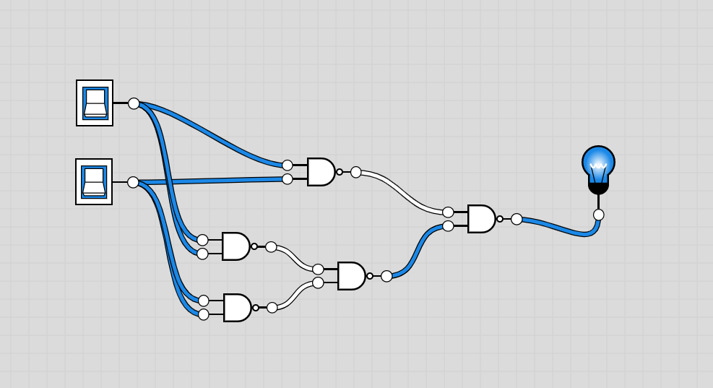

|  |  |  |
| --- | --- | --- |
| Input 1 | Input 2 | Output |
| 1 | 1 | 1 |